**Traffic Manager Profile for an existing Web App**

**Azure Traffic Manager is a traffic load balancer that distributes traffic optimally to services under different global Azure regions while providing the high responsiveness.**

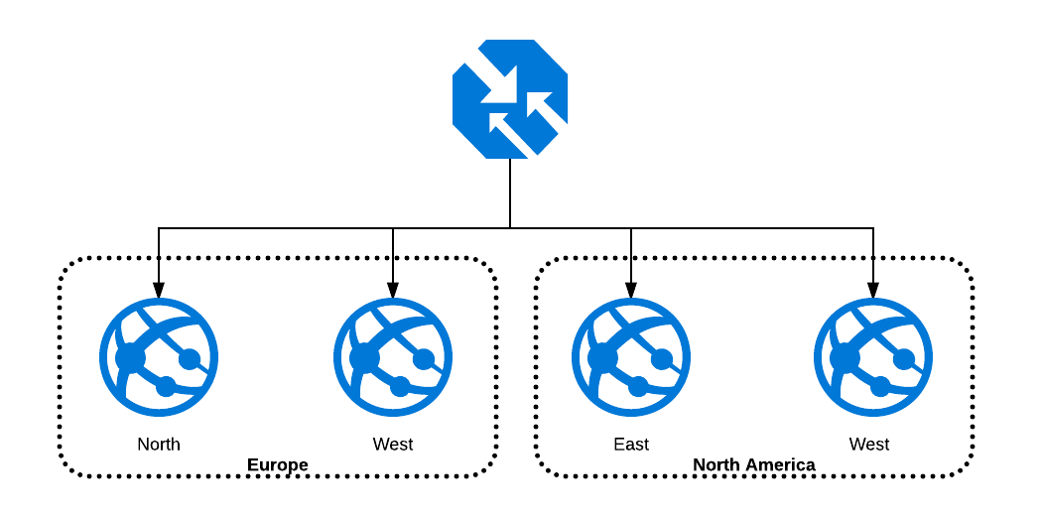

Traffic Manager uses DNS to direct client requests to the most appropriate service endpoint based on chosen [**traffic-routing method**](https://docs.microsoft.com/en-us/azure/traffic-manager/traffic-manager-routing-methods).

**PREREQUISITES**:

* You need to have an active Azure Subscription. If you not have you can sign-up for a free [**Account**](https://azure.microsoft.com/en-in/free/) **.**
* An existing Web App hosted in Azure. For creating a Web App you can follow this [**blog**](https://www.c-sharpcorner.com/blogs/creating-an-azure-web-app-and-enabling-security-authentication2) .

**Task 1st** : Creating traffic manager Profile.

* Navigate to the[**Azure Portal**](https://portal.azure.com/).
* Go to the existing Resource group.
* See here resource group ‘testingforblog’.

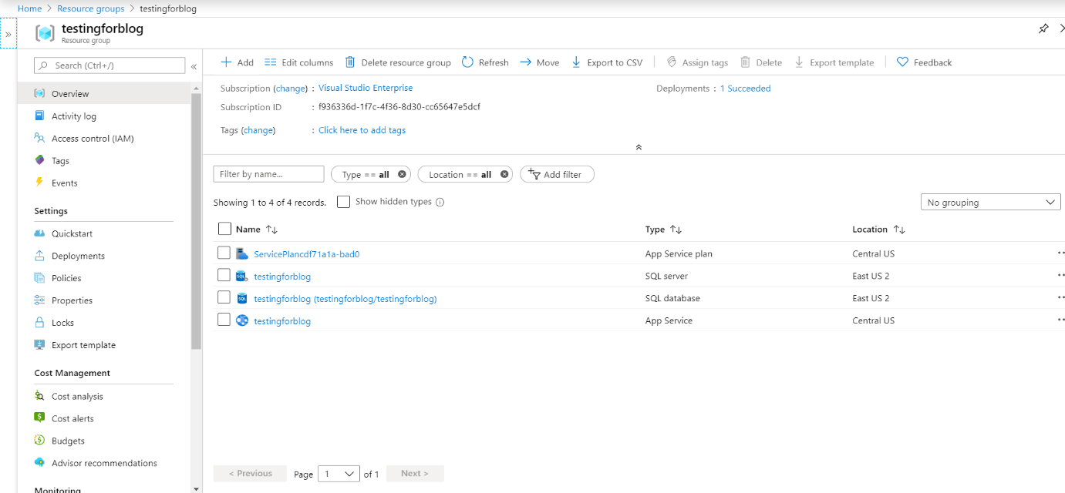

* Click on Add. You will move to market place and choose traffic manager Profile.

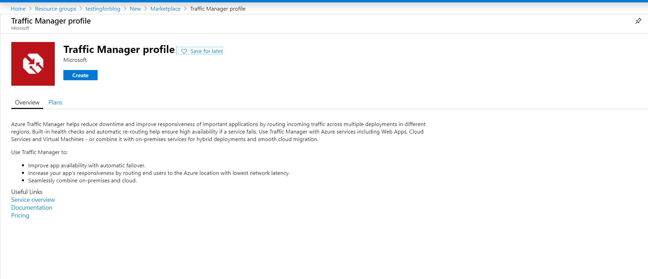

* Click on Create.
* Once you click it you will see a Panel that contains following things :
* you need to fill in the following information.

1. Name: Enter a unique name for your Traffic Manager profile.
2. Routing Method: Select Priority.
3. Subscription: Select the subscription you want the traffic manager profile applied to.
4. Resource group: Select your resource group.
5. Location: It is the location of your resource group.

* Select Create.
* Pin the Deployed resource to the Dashboard. So,Our 1st task is Completed. Now we will move to our next task.

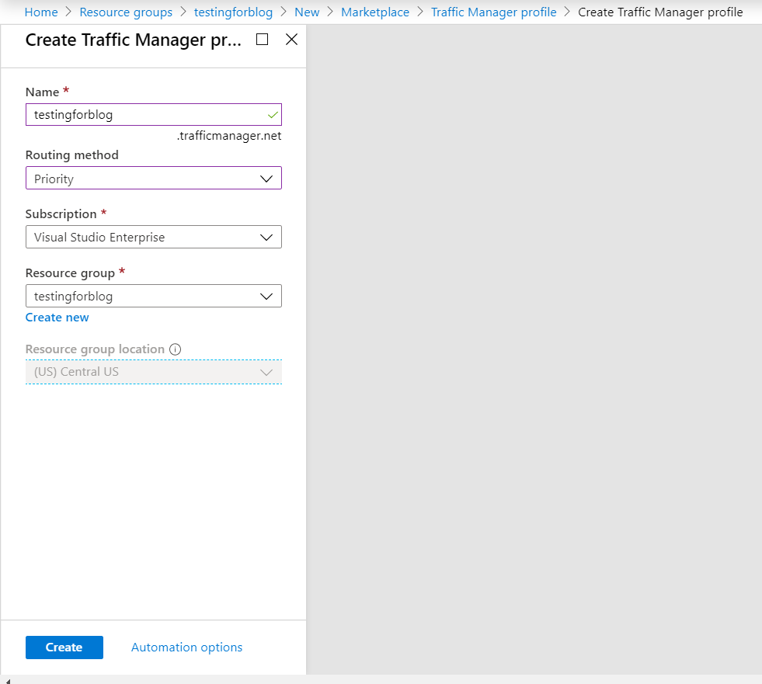

**Task 2nd** : Add Traffic Manager endpoints

* In **Traffic Manager profile**, in the **Settings** section, select **Endpoints**, and then select **Add**.

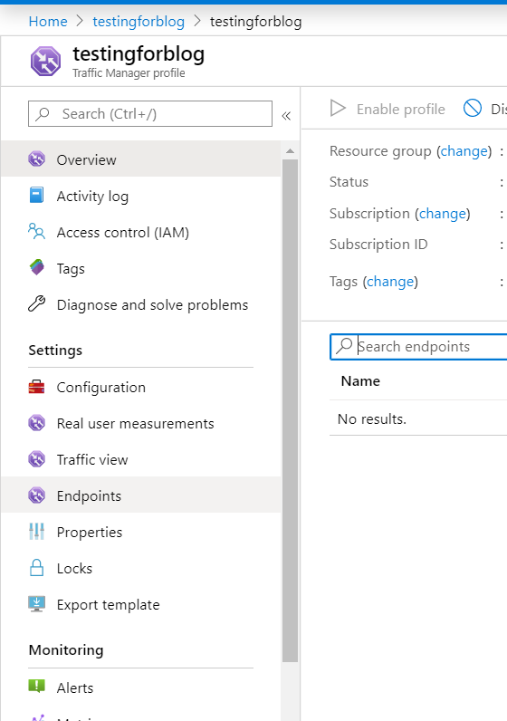

* Once you click it you will see a Panel that contains following things :
* you need to fill in the following information.

1. Type: Select Azure Endpoint.
2. Name: Enter any name.
3. Target resource type: Select **App Service**.
4. Target resource: Select **Choose an app service** > **Central US**.
5. Priority: Select **1**. All traffic goes to this endpoint when it's healthy.

* Select OK.

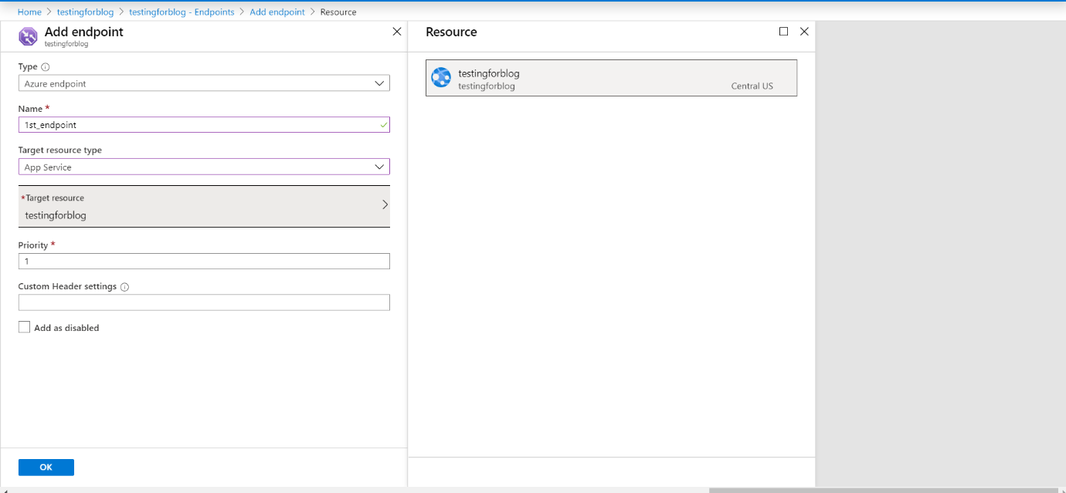

* You will see this.

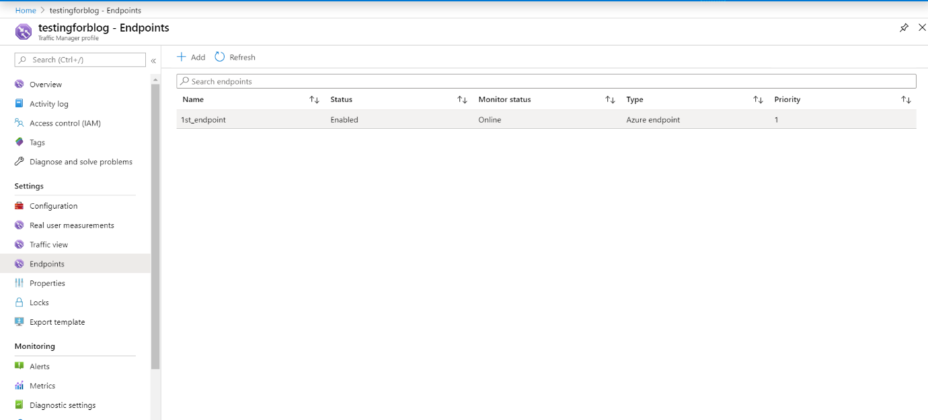

**Note**: So finally we have completed our both tasks.